BRETHREN

a new work for ‘roaming orchestra’
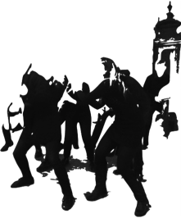
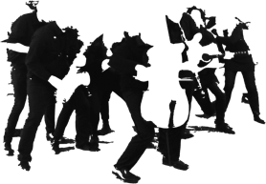
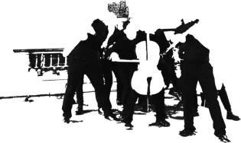
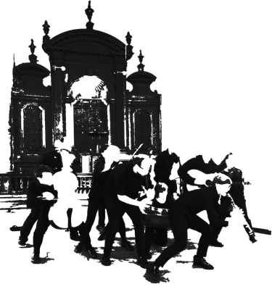
combining music & movement
by James Whittle

Call for performers
for the premiere on 4th May 2016

open to instrumental players of all abilities

Find out more & how to take part overleaf

What is BRETHREN?
BRETHREN is a 30-minute performance piece about community and conflict.
Imagine an empty stage, dimly lit. A single violinist walks onto it and begins to play. Another joins. Then more. Soon they form a group, while others emerge: cellists, clarinetists, flautists, all clustering in groups. The way they move and the way they play are all different. Their sounds and shapes build, clash and combine. From chaos, something must be salvaged.
Using the metaphor of an orchestra as a collection of instrumental families, BRETHREN will explore how a community caught in conflict, how peoples upheaved and isolated, can rebuild and move forward as one.
The title comes from words sung in Leonard Bernstein’s Chichester Psalms: ‘how good it is for brethren to dwell together in unity’.
Who can perform in BRETHREN?
Any musician, on any instrument associated with the orchestra. The only instruments that cannot be in the piece are pianos and large percussion instruments.
The BRETHREN orchestra will include two University of York Music Department ensembles: The Assembled and Chimera Ensemble. The rest of the orchestra will involve musicians based in York and other students. Performers will be in groups, arranged by instrumental type and by instruments that move in similar ways (e.g. violins with violas, clarinets with oboes). The choreographed or ‘roaming’ BRETHREN orchestra will inhabit the stage without music stands, without conductor.
What do I need to take part in BRETHREN? What will I be doing in it?
Comfortable clothing for moving in, enthusiasm and a willingness to try something new!
You will be moving around – roaming! – and forming tableaux on stage, with your instrument, alongside other musicians. Any experience of theatre, dance or movement is a plus but is not necessary for the piece. The orchestra will not be required to act: the focus will be on the sound and on the natural movements we make when we play our instruments.
Rehearsals will be directed and supervised by James throughout. These will start with gentle physical warm-ups, plus games to develop spatial awareness and musical improvisation skills. The orchestra will learn stage and musical directions together by rote, building the piece bit by bit.
What will the music be like?
The first part of the piece, ‘VIOLINS’, will feature each instrumental group building its own block of sound. Gradually, energy and density will grow. The second part, ‘VIOLENCE’, will be quite noisy as the blocks of sound clash. In the third part, ‘SILENCE’, the blocks of sound will complement, interact and combine with each other. There will be silences too!
The music will comprise short composed passages and moments of improvisation. If you are new to improvisation, there is nothing to worry about: instructions for what to do will always be straightforward and structured.
Where & when are rehearsals?
- Dates: 16th, 17th, 23rd & 24th April, 1st & 4th* May (*=run-through only)
- Venue: University of York Music Department
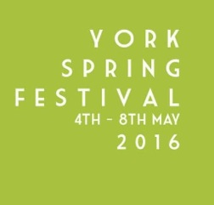
Where & when is the performance?
- Date: Wednesday 4th May, 7.30pm
- Venue: Sir Jack Lyons Concert Hall, University of York
- Part of York Spring Festival:
www.yorkspringfestival.co.uk | www.york.ac.uk/concerts
- View the hall: www.york.ac.uk/music/about/facilities/performance/
How can I get to the rehearsal and performance venues?
There is parking on campus & regular buses. Here are some helpful transport & map links:
- www.york.ac.uk/about/maps/campus/
- www.york.ac.uk/admin/estates/transport/parking/
- www.york.ac.uk/admin/estates/transport/public_transport/bus/
Finally… who is James Whittle?
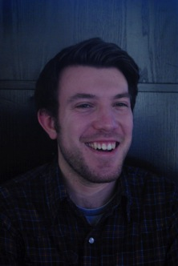
I am a composer, theatre-maker, conductor and cellist based at the University of York. I am finishing a PhD in Composition, titled ‘Music is Theatre’. I am fascinated by the visual side & physicality of musical performance. My research into combining music & movement has led to BRETHREN.
© Morag Galloway
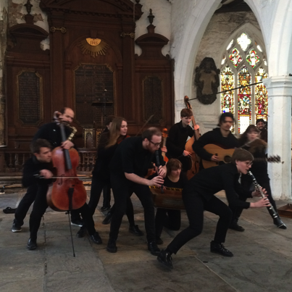
My background is in collaboration. I have worked with professional & young musicians, contemporary dancers & choreographers, performance artists & theatre-makers. I am currently Composer-in-Residence with Castaway Goole Accessible Music Theatre.
You can watch & listen to my work here:
- www.youtube.com/user/jameswhittle7
- www.soundcloud.com/james-whittle
How to contact James
jw637@york.ac.uk | +44 (0)7415 520488
The Assembled perform James’ piece my my mime
at St Michael-cum-Gregory, Micklegate, May 2015
© Jin Hyung Lim
www.james-whittle.co.uk | @JWW_composes
BRETHREN Orchestra membership form
If you would like to perform in BRETHREN,
please complete this form & email it to James: jw637@york.ac.uk
Your information will be kept confidentially and deleted after the performance.

Name:____________________________________________________
Email address: ____________________________________________
Mobile number:____________________________________________
Instrument: _______________________________________________
Instrumental Grade/Standard:________________________________
Rehearsal Availability:
- Please tick 1 box on each row (if on a computer you can copy & paste this symbol: ✓)
- If you can only attend some parts of a rehearsal, please list the times you can attend.
Date | Time | I can attend this rehearsal. | I can attend some of this rehearsal (please list times). | I cannot attend this rehearsal.
Sunday 17th April | 1—4pm
Saturday 23rd April | 1—4pm
Sunday 24th April | 12—3pm
Sunday 1st May | 10—3pm
Wednesday 4th May  run-through | 5—6.30pm
Wednesday 4th May  concert | 7.30—9pm

Declaration:
I agree to participate in the performance of BRETHREN and confirm that I will attend all the rehearsals and performance dates as detailed above.

Signed:__________________________________________________________________

Thank you — I look forward to meeting you!

